**Project 1 - ‘Kiva’ App**

Joseph Dengler

Southern New Hampshire University

CS-319: UI / UX Development

Prof. Jessica Carey

6/23/2024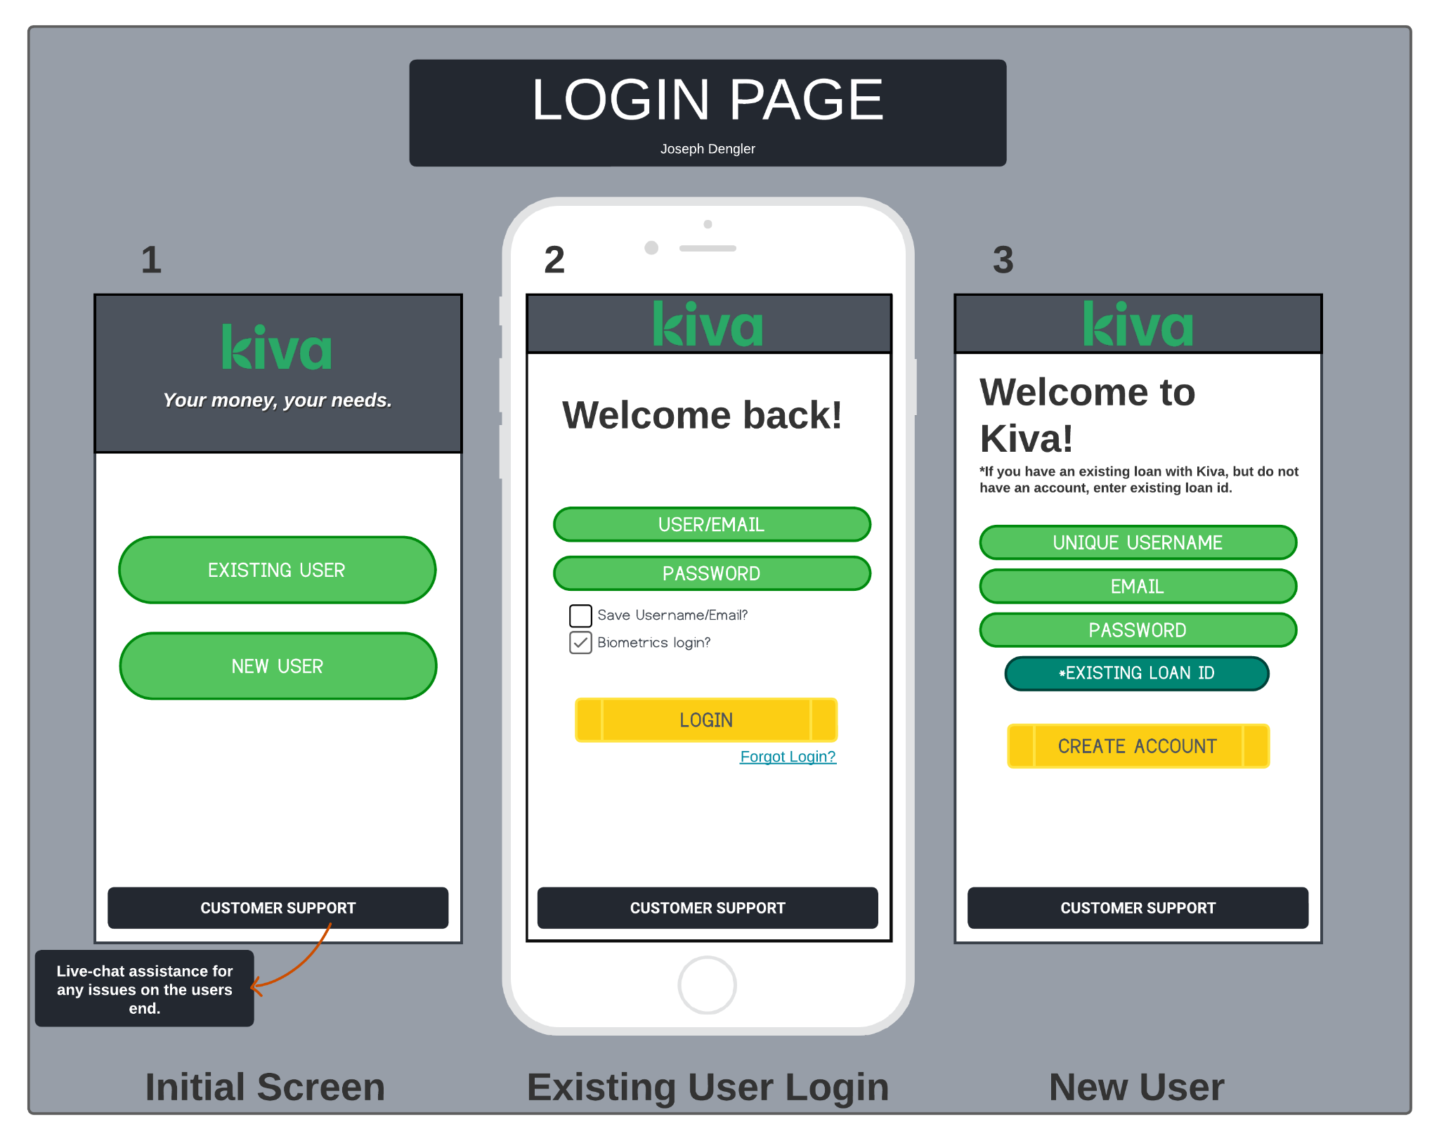

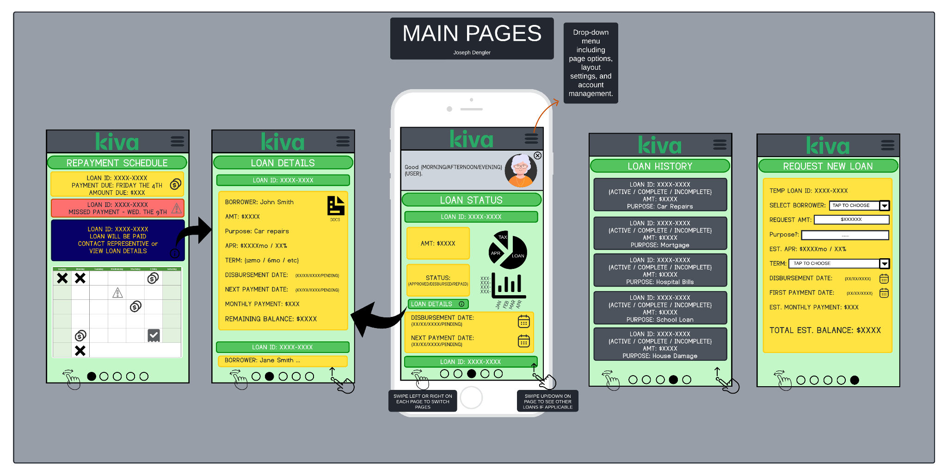

**UI/UX Design for Kiva Borrower Application**

For the main screen of the Kiva embedded application, I designed a user-friendly interface tailored for borrowers using smartphones. The primary components include a header with the Kiva logo and a personalized greeting, a main menu with options for Loan Status, Loan Details, Repayment Schedule, Loan History, and Request Loan, and a footer with navigation dots to swipe between pages. Users can also tap directly on a specific dot to access a desired section immediately. This intuitive navigation ensures that users can efficiently manage their loans, stay informed, and make necessary adjustments with ease.

Additionally, the login screen is designed to be straightforward and secure. It includes an initial screen with options for existing users and new users. Existing users can log in with their credentials, while new users can create an account. There is also a customer support option for live-chat assistance, ensuring users can resolve any issues quickly. This initial login process is crucial for maintaining security and providing a personalized experience right from the start.

**Explanation of Data Access and User Interactions**

Users will access data through straightforward menu-driven interactions. Selecting "Loan Status" shows the loan ID, amount, status, disbursement date, and next payment date. "Loan Details" provides comprehensive information about each loan, including borrower name, loan amount, purpose, APR, term, disbursement date, next payment date, monthly payment, and remaining balance. The "Repayment Schedule" displays upcoming payment dates, amounts due, and any missed payments, while "Loan History" lists past loans with detailed performance metrics. Finally, the "Request Loan" screen simplifies the process of applying for a new loan, ensuring that users can submit their requests effortlessly.

**Rationale Behind Design Choices**

The purpose and function of each element and screen in the wireframe are to provide borrowers with a clear, concise, and efficient means of managing their loans. The main menu allows users to quickly access different sections, while the navigation dots enhance ease of movement between screens. This design benefits borrowers by ensuring they can access vital information and perform necessary actions without unnecessary complexity. For Kiva, this design enhances user satisfaction and engagement, promoting better loan management and repayment rates.

Innovative solutions developed to adapt to challenges include the use of intuitive navigation dots for quick access to different sections and the implementation of clear, easy-to-read data presentation formats. Previous research into user behavior and needs supported decisions such as prioritizing loan status and repayment schedules on the main screen, ensuring that the most critical information is always readily available.

**Lender Cloud-Based System Recommendation**

For the cloud-based system, it is crucial to align the design with Kiva’s vision and mission. The system should facilitate transparent, secure, and user-friendly interactions. Effective communication between application components is essential, ensuring seamless integration of borrower applications, repayment schedules, and loan histories. This can be achieved using APIs and secure data exchange protocols to provide real-time updates and accurate data sharing between borrowers and lenders.

To ensure alignment with Kiva's business vision and mission, the cloud-based system must prioritize transparency and ease of use, providing clear insights into borrower requests and lending activities. Communication between application components should be streamlined using robust APIs that facilitate secure and efficient data exchanges. This approach not only supports real-time updates but also enhances the accuracy of shared information, which is vital for maintaining trust and reliability. Optimizing communication among components involves implementing standardized protocols and ensuring that all data transactions are encrypted and secure, thereby safeguarding user information and enhancing system integrity.

Different lenders have varied goals. Some may focus on high-impact loans, while others might be interested in frequent smaller loans. The cloud application should provide customizable views and analytics to cater to these diverse needs. By offering detailed insights and user-friendly interfaces, lenders can make informed decisions and manage their lending portfolios effectively. Next steps include planning and building this system with a focus on optimizing communication among components and ensuring that the design aligns with Kiva's mission and the varied goals of its lenders.

**Balancing Creativity with Kiva's Code of Conduct**

In developing this design, I considered Kiva's code of conduct, particularly the principles of respecting users and their dignity. Respecting user data means ensuring that personal and financial information is displayed securely and appropriately while also recognizing the dignity of both borrowers and lenders. Transparency is achieved by providing clear and accurate information about loans and repayments, enabling borrowers to make informed decisions. By adhering to these principles, the design not only serves the functional needs of the users but also upholds Kiva's commitment to ethical and responsible financial services. This approach ensures that borrowers feel supported and confident in managing their loans through the Kiva platform, thereby contributing to Kiva's mission of eradicating poverty through microfinance.

**Conclusion**

The UI/UX design for the Kiva borrower application successfully integrates the necessary data and user interactions to create a seamless and user-friendly experience. By focusing on the key needs of borrowers and adhering to design best practices and ethical guidelines, this prototype provides a strong foundation for further development and implementation.

**SOURCES / REFERENCES**

Sharp, Helen. Interaction Design: Beyond Human-Computer Interaction, Fifth Edition. Wiley & Sons Canada, Limited, John, 2019.

“KIVA - Code of Conduct.” Kiva, www.kiva.org/build/code-of-conduct.

“Loans That Change Lives.” Kiva, www.kiva.org/lend/filter?sortBy=popularity.